ОТЧЁТ
по лабораторной работе #1
на тему «Статика»

Вариант # | 0
Выполнили: ст. гр. М7О-110БВ-25 | Илья Ильф
Выполнили: ст. гр. М7О-110БВ-25 | Евгений Петров

1. Механическая система и силы
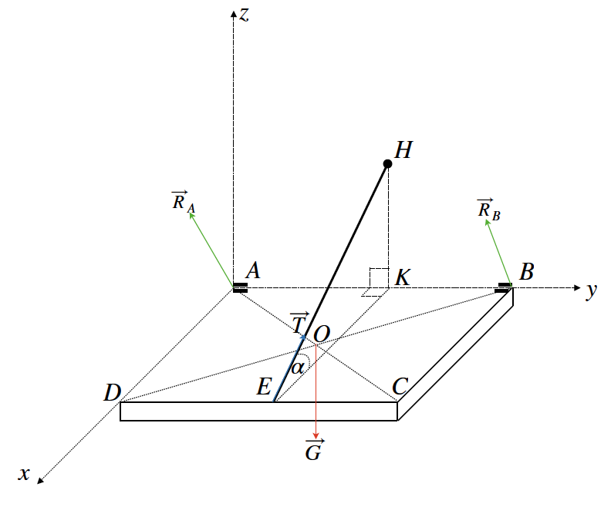
$AK=a$, $KB=b$, $BC=c$

2. Проекции сил и координаты точек приложения (неизвестные подчёркнуты)
Сила | Ox | Oy | Oz | Точка | Ox | Oy | Oz
$$\vec{G}$$ | $$0$$ | $$0$$ | $$-G$$ | $$O$$ | $$\frac{c}{2}$$ | $$\frac{a+b}{2}$$ | $$0$$
$\vec{T}$ | $$-\underline{T}\cos{α}$$ | $$0$$ | $$\underline{T}\sin{α}$$ | $$E$$ | $$c$$ | $$a$$ | $$0$$
$$\vec{R_{A}}$$ | $${\underline{R}}_{Ax}$$ | $$0$$ | $${\underline{R}}_{Az}$$ | $$A$$ | $$0$$ | $$0$$ | $$0$$
$$\vec{R_{B}}$$ | $${\underline{R}}_{Bx}$$ | $$0$$ | $${\underline{R}}_{Bz}$$ | $$B$$ | $$0$$ | $$a+b$$ | $$0$$

3. Система уравнений равновесия (получена в MAPLE)
$$-T\cos\left(α\right)+R_{Ax}+R_{Bx}=0$$
$$0=0$$
$$-G+T\sin\left(α\right)+R_{Az}+R_{Bz}=0$$
$$T\sin\left(α\right)a+R_{Bz}\left(a+b\right)=0$$
$$\frac{Gc}{2}-T\sin\left(α\right)c=0$$
$$T\cos\left(α\right)a-R_{Bx}\left(a+b\right)=0$$

4. Общее решение системы
$$T=\frac{G}{2\sin\left(α\right)}$$
$$R_{Ax}=\frac{G\cos\left(α\right)b}{2\sin\left(α\right)\left(a+b\right)}$$
$$R_{Az}=\frac{G\left(2a+b\right)}{2\left(a+b\right)}$$
$$R_{Bx}=\frac{G\cos\left(α\right)a}{2\left(a+b\right)\sin\left(α\right)}$$
$$R_{Bz}=-\frac{Ga}{2\left(a+b\right)}$$
Замечание: от параметра $c$ ничего не зависит.

5. Числовые значения параметров задачи
$a=30\left(см\right)=0.3\left(м\right)$; $b=20\left(см\right)=0.2\left(м\right)$; $α={30}^{∘}$; $G=10\left(кН\right)$.

6. Результаты вычислений
$T=10\left(кН\right)$; $R_{Ax}=3.4641\left(кН\right);$ $R_{Az}=8\left(кН\right)$; $R_{Bx}=5.1962\left(кН\right)$; $R_{Bz}=-3\left(кН\right)$.

7. Листинг программы (см. приложение)
ЛАБОРАТОРНАЯ РАБОТА #1

restart;

1. Зададим количество сил в системе.
N := 4;
N := 4

2. Зададим проекции всех сил.
Forces := Array(1 .. N, 1 .. 3);
[0 0 0]
[ ]
[0 0 0]
Forces := [ ]
[0 0 0]
[ ]
[0 0 0]
Forces[1, 1] := 0; Forces[1, 2] = 0; Forces[1, 3] := -G;
Forces[1, 1] := 0
0 = 0
Forces[1, 3] := -G
Forces[2, 1] := -T*cos(alpha); Forces[2, 2] := 0; Forces[2, 3] := T*sin(alpha);
Forces[2, 1] := -T cos(alpha)
Forces[2, 2] := 0
Forces[2, 3] := T sin(alpha)
Forces[3, 1] := R[Ax]; Forces[3, 2] := 0; Forces[3, 3] := R[Az];
Forces[3, 1] := R[Ax]
Forces[3, 2] := 0
Forces[3, 3] := R[Az]
Forces[4, 1] := R[Bx]; Forces[4, 2] := 0; Forces[4, 3] := R[Bz];
Forces[4, 1] := R[Bx]
Forces[4, 2] := 0
Forces[4, 3] := R[Bz]

3. Зададим координаты всех точек приложения.
Points := Array(1 .. N, 1 .. 3);
[0 0 0]
[ ]
[0 0 0]
Points := [ ]
[0 0 0]
[ ]
[0 0 0]
Points[1, 1] := c/2; Points[1, 2] = (a + b)/2; Points[1, 3] := 0;
1
Points[1, 1] := - c
2
1 1
0 = - a + - b
2 2
Points[1, 3] := 0
Points[2, 1] := c; Points[2, 2] := a; Points[2, 3] := 0;
Points[2, 1] := c
Points[2, 2] := a
Points[2, 3] := 0
Points[3, 1] := 0; Points[3, 2] := 0; Points[3, 3] := 0;
Points[3, 1] := 0
Points[3, 2] := 0
Points[3, 3] := 0
Points[4, 1] := 0; Points[4, 2] := a + b; Points[4, 3] := 0;
Points[4, 1] := 0
Points[4, 2] := a + b
Points[4, 3] := 0

4. Получим уравнения равновесия.
eq1 := sum(Forces[k, 1], k = 1 .. N) = 0;
eq1 := -T cos(alpha) + R[Ax] + R[Bx] = 0

eq2 := sum(Forces[k, 2], k = 1 .. N) = 0;
eq2 := 0 = 0

eq3 := sum(Forces[k, 3], k = 1 .. N) = 0;
eq3 := -G + T sin(alpha) + R[Az] + R[Bz] = 0

eq4 := sum(-Forces[k, 2]*Points[k, 3] + Forces[k, 3]*Points[k, 2], k = 1 .. N) = 0;
eq4 := T sin(alpha) a + R[Bz] (a + b) = 0

eq5 := sum(Forces[k, 1]*Points[k, 3] - Forces[k, 3]*Points[k, 1], k = 1 .. N) = 0;
1
eq5 := - G c - T sin(alpha) c = 0
2

eq6 := sum(-Forces[k, 1]*Points[k, 2] + Forces[k, 2]*Points[k, 1], k = 1 .. N) = 0;
eq6 := T cos(alpha) a - R[Bx] (a + b) = 0

5. Выпишем систему целиком. Сформируем список неизвестных.
eqs := {eq1, eq2, eq3, eq4, eq5, eq6};
/ 1
eqs := { 0 = 0, - G c - T sin(alpha) c = 0,
\ 2
T cos(alpha) a - R[Bx] (a + b) = 0,
T sin(alpha) a + R[Bz] (a + b) = 0,
-T cos(alpha) + R[Ax] + R[Bx] = 0,
\
-G + T sin(alpha) + R[Az] + R[Bz] = 0 }
/

variables := {T, R[Ax], R[Az], R[Bx], R[Bz]};
variables := {T, R[Ax], R[Az], R[Bx], R[Bz]}

6. Решим систему уравнений равновесия.
sol := solve(eqs, variables);
/ G G cos(alpha) b
sol := { T = ------------, R[Ax] = --------------------,
\ 2 sin(alpha) 2 sin(alpha) (a + b)
G (2 a + b) G cos(alpha) a
R[Az] = -----------, R[Bx] = --------------------,
2 (a + b) 2 (a + b) sin(alpha)
G a \
R[Bz] = - --------- }
2 (a + b)/

7. Подставим значения параметров.
Spar := {G = 10, a = 0.3, alpha = Pi/6, b = 0.2};
/ 1 \
Spar := { G = 10, a = 0.3, alpha = - Pi, b = 0.2 }
\ 6 /
evalf(subs(Spar, sol));
{T = 9.999999995, R[Ax] = 3.464101614, R[Az] = 8.000000000,

R[Bx] = 5.196152421, R[Bz] = -3.000000000}

